Bug Hypothesis and Tracing

*Bug Name – Return Book Incorrect Fine*

# Hypothesis of cause

|  |  |  |
| --- | --- | --- |
| Hypothesis | Description | Was this the cause? |
| The error is in the library class calculation | Since this method is called and the logic of the returnbookcontrol looks fine | No |
| The error is in the calendar class getDays Difference | Since this method calculates the difference in days, which is used to calculate the fine, this may be the error | Yes |

# Tests to narrow down bug

## Idea

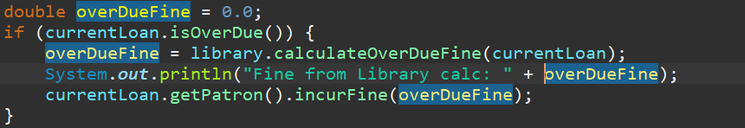

This will attempt to see if the overduefine is calculated correctly from the library class. (7:43pm 18/10/2020 Line 53 - ReturnBookControl)

### Output:



### Conclusion:

From this, we can see that the call to a method in the library class has the issue

## Idea 2

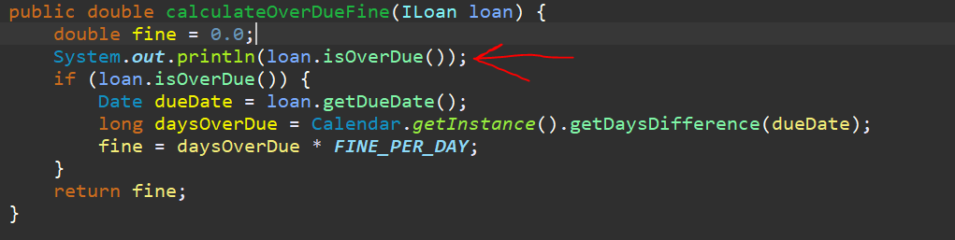

The reason why I tried this is to try and see whether the if statement is not detected the loan is overdue. Hence this would prove whether there is an issue in the actual if statement itself.

### Output



### Conclusion

The bug must be further within the method, within the IF statement

## Idea 3

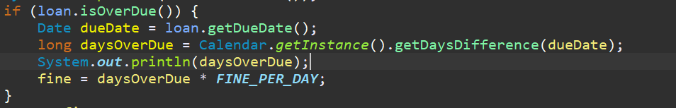

This will test to see if the system calculates that there is 1 day difference between the two dates.

### Output

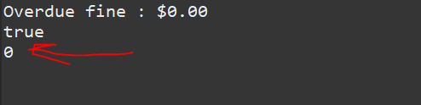

### Conclusion

Hence due to the fact this value returned 0, the error is in this section. Specifically in Library Entity class, Line:

It is likely the error is in the Calendar class, in the getDaysDifference method.

## Idea 4

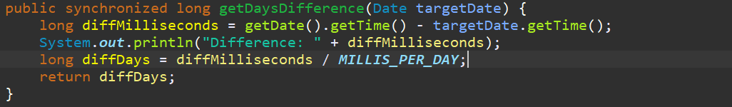

This tests whether a difference is calculated, this value should be positive if there is a difference.

### Output

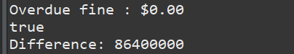

### Conclusion

The error must be further down the method, since it is showing a difference between the dates.

## Idea 5

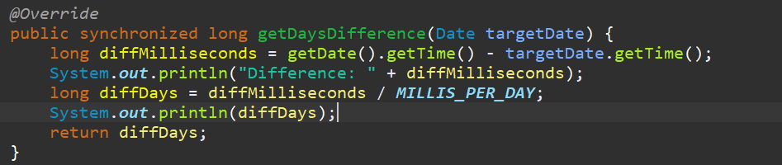

### Output

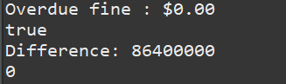

### Conclusion

The issue is between one of the values, diffMilliseconds and MILLIS_PER_DAY.

We have tested the diffMilliseconds and can show that the value for a difference of 1 day is 86400000. Hence the second value needs to be checked.

## Idea 6

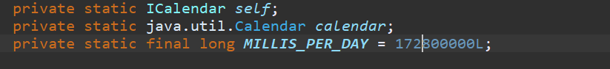

Since this is a value and not a method, we do not need to test the output of a method.

### Conclusion:

The calculation done by the calendar class highlights 1 day is 86400000, whereas this shows it to be a much bigger number. It is this value that would mean that the number rounds down to 0. Hence changing this value should allow the program to calculate fines correctly.

# Issue Resolution

## Original “buggy” line:

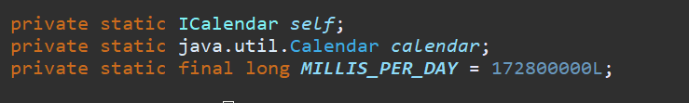

## Fixed line:

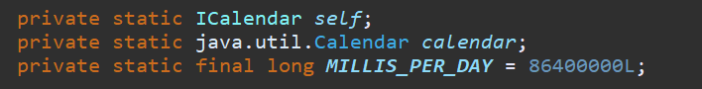

## Proof of fix (Automated test):

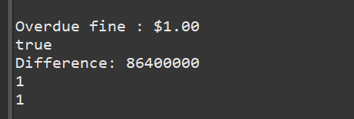

We can now see that our test values show correctly that there is 1 days difference, and hence a $1 fine is imposed.

## Proof of fix (Manual Test):

